**iDD-212G**

**User Manual**

**(Rev.2.0)**

Shenzhen Sinocastel Electronics Technology Investment Co., Ltd

November, 2011

**Contents**

1. Introduction 2

2. Packing List 2

3. Specifications 2

**3.1** **External interface** 2

**3.2** **Technical Parameters** 2

4. Functions 2

**4.1** **Protocols** 2

**4.2** **GPS** 2

**4.3** **Real-time Monitoring** 2

**4.4** **Vehicle’s Location** 2

**4.5** **Abnormal Alert** 2

**4.6** **Mileage of Trip** 2

**4.7** **Fuel Consumption of Trip** 2

**4.8** **Remote Maintenance** 2

**4.9** **Diagnostic Functions** 2

5. Installation 2

**5.1** **Account Registration** 2

**5.2** **SIM Card Installation** 2

**5.3** **Parameter Settings** 2

**5.4** **Device Installation** 2

**5.5** **Diagnostic Link Connector** 2

**5.6** **Using** 2

6. Disclaimer 2

7. Warranty 2

8. FAQ 2

9. Statement 2

1. **Introduction**

This product is an intelligent electronic terminal for automotive. It bases on OBD II/EOBD standard, with tracking, alarming, and remote diagnostic function. It combines the world leading technology of Global Position System (GPS), the technology of General Packet Radio Service (GPRS) and the technology of intelligent controlling all in one.

The product is consisted with OBD diagnostic module and GSM communication module, and has optional external G-Mouse (Model: HT-166U). This terminal will deliver vehicles live data and GPS information to the control center via GPRS. The center will analyze, statistic, store and display to users.

1. **Packing List**

|  |  |  |
| --- | --- | --- |
| **Parts name** | **Quantity** | **Note** |
| iDD-212G Device | 1 | ● |
| USB Data Cable | 1 | ● |
| Product Handbook | 1 | ● |
| G-Mouse Receiver (HT-166U) | 1 | ○ |
| OBD Connector Extension Cord | 1 | ○ |

Note● Standard configuration ○ Optional configuration

(If not select any when ordering, the optional devices will not be included when packing)

1. **Specifications**
2. **External interface**

Product shape shown in the following figure.

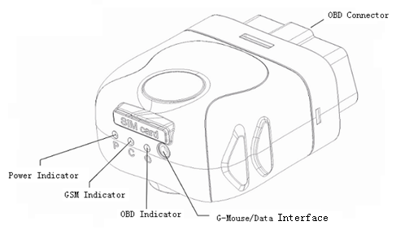

1. **OBD Connector**

It is used to connect with the on-board Diagnostic Link Connector.

The OBD system communicates with external device under the same protocol through this connector.

1. **G-Mouse/Data Interface**

This is a multifunction interface. Device connects to PC by USB Data Cable through this connector when modify the parameters of the device. In normal, this interface can be accessed by G-Mouse accessories.

1. **SIM Card Interface**

This is used for inserting the SIM card.

1. **Status Indicator**

|  |  |  |
| --- | --- | --- |
| **Indicator** | **Color** | **Status** |
| Power LED | Red | Permanently on - Power on |
| GSM LED | Orange red | Slow blinking (on:0.3s, off:2.7s) - Registered full service  Fast blinking (on:0.5s, off:0.5s) - Network searching/Not registered  Permanently off - Module off |
| OBD LED | Green yellow | Blinking - Device try to communicate with vehicle  Permanently on - Device communicate with vehicle |
| G-Mouse LED | Green | Blinking - GPS signal is good  Permanently on - Searching the GPS signal |

1. **Technical Parameters**

|  |  |  |  |
| --- | --- | --- | --- |
| Working voltage | 9~16V DC | Normal current | <150 mA@13.8V |
| Locate mode | GPS | Sleep current | <35mA@12.0V |
| Location accuracy | ≤15m | Max current | <200mA@13.8V |
| Locate speed  accuracy | ≤0.1m/s | Working temp | -30℃～+70℃ |
| Transmission | GPRS/SMS | Storage temp | -40℃～+85℃ |
| GSM band | 850/900/  1800/1900MHz | Relative humidity | 5%～95%no frost |
| Dimension | 55*50*28mm  (L*W*H) | Protection class | IP30 |

1. **Functions**
2. **Protocols**

This product supports all the OBD II standards below:

* J1850-PWM
* J1850-VPW
* ISO 9141-2
* ISO 14230-4 (KWP2000)
* ISO15765-4(CAN)

1. **GPS**

This product has a GPS satellite signal receiver for enabling global positioning.

1. **Real-time Monitoring**

This product can keep contact with control center through GSM features for enabling real-time monitoring.

1. **Vehicle’s Location**

User can visit our tracking platform to check vehicle’s position.

1. **Abnormal Alert**

When the following conditions beyond the pre-defined value, the device will send out an extension alarm to the control center and accompanied with “beep-beep-beep...”.

The conditions including:

* High RPM
* High Speed
* Low Battery Voltage
* High Coolant Temperature
* Quick Speed-up
* Quick Slow-down
* Parking long time without ignition off
* Towed

Note: For details, please see this handbook – Installation | Parameter Setting.

1. **Mileage of Trip**

At the end of the trip, device will report the driving mileage to the control center.

1. **Fuel Consumption of Trip**

At the end of the trip, device will report the fuel consumption to the control center.

1. **Remote Maintenance**

The parameters of device can be modified through our website

1. **Diagnostic Functions**

Upon user’s request, this product can read/erase diagnostic trouble codes, reset the MIL, and many live data.

All of the information can be analyzed by the control center, and immediately display to the user with provision of maintenance recommendations to prevent the extension damages and costs.

1. **Installation**
2. **Account Registration**

Please contact CASTEL to open an account

1. **SIM Card Installation**

Remove the SIM card slot cover and insert the SIM card into the card slot (Note: SIM card gap and slot miter edge must fit), then replace the device cover (Note: Align the SIM card within the SIM card slot and gently push).

1. **Parameter Settings**

Please connect the device to PC by using the supplied USB data cable. And then run the OBD PCTool program after a beep sound. The software GUI is shown below:

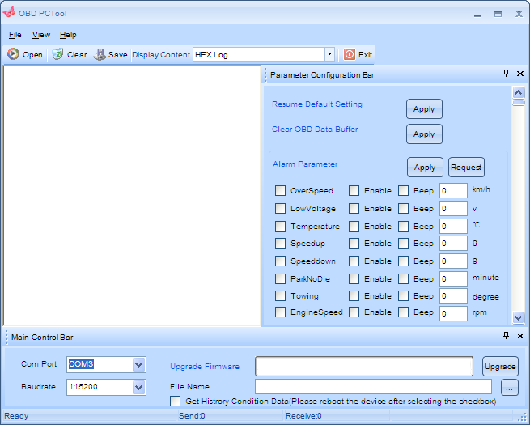

Select a correct value for Com Port, and then click the button Open at the top of the window.

Locate the parameters you want by scrolling the scrollbar on the right of the window.

For example the Alarm Parameter, click the button Request to retrieve the current settings in the device, shown as below:

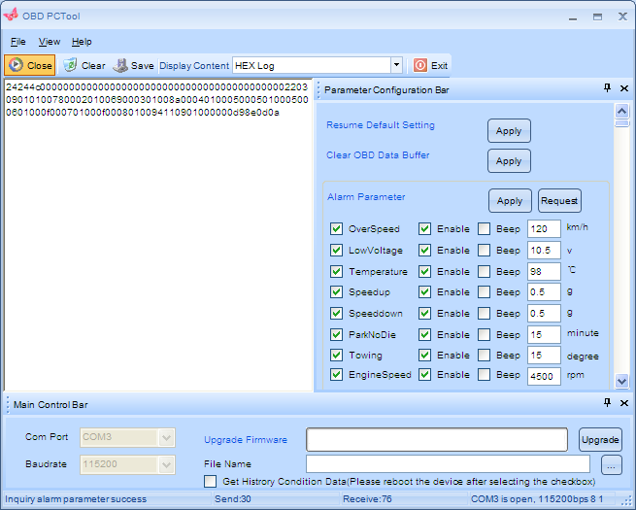

You can modify the values as you want, and then click the button Apply to store them back into device.

The same as others, you can find more in the user manual of OBD PCTool.

1. **Device Installation**

Stop and turn off the engine and insert the G-Mouse into the G-Mouse Connector. Light up and flat on the vehicle. Ensure that there is no block of metal and other items. At the end, please connect the device to the OBD diagnostic connector firmly.

1. **Diagnostic Link Connector**

Vehicle equipped with OBD system has an DLC on board according to the specification

of J1962. Shown as below:

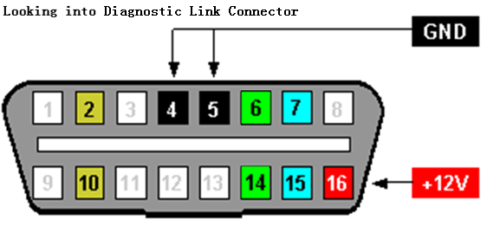

|  |  |  |  |
| --- | --- | --- | --- |
| **Pin** | **Description** | **Pin** | **Description** |
| 1 | Vendor Option | 9 | Vendor Option |
| 2 | SAE J1850 Bus+ | 10 | SAE J1850 Bus- |
| 3 | Vendor Option | 11 | Vendor Option |
| 4 | Chassis Ground | 12 | Vendor Option |
| 5 | Signal Ground | 13 | Vendor Option |
| 6 | ISO 15765-4 (CAN) High | 14 | ISO 15765-4 (CAN) Low |
| 7 | ISO 9141-2 K-Line | 15 | ISO 9141-2 L-Line |
| 8 | Vendor Option | 16 | Battery Power |

In general, the DLC is located within the driver or passenger cabin, from the edge of dashboard on driver side to the border of 300mm crossed the vehicle centerline on passenger side. It is easy to touch by sitting in the driver's seat, the preferred location is within the area from steering post to the vehicle centerline. Shown as below:

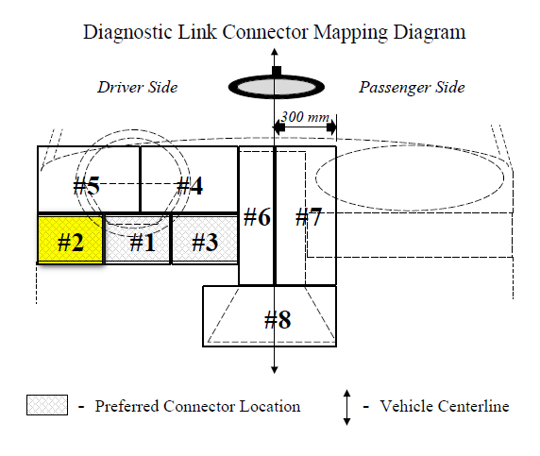

1. **Using**

The red led (Power LED) lights on permanently after the device connected to the on-board Diagnostic Link Connector, accompanied with "beep" one-tone that means power is on.

If the device’s time is not the same as current actual time, the orange red led (GSM LED) blinks fast, it means the device is searching GSM network, later, if the led blinks slow, and accompanied with "beep-beep-beep" three-tones that means the device registered to the GSM network, then the Control Center will synchronize the device’s time. At the same time, the green yellow led (OBD LED) blinks fast that means the device is communicating with the vehicle’s ECU. Now, start the engine, a little later, the green yellow led blinks slowly, accompanied with "beep-beep" two-tones that means the communication has been established.

If the device’s time is the same as current actual time, the green yellow led (OBD LED) blinks fast that means the device is communicating with the vehicle’s ECU. Now, start the engine, a little later, the green yellow led blinks slowly, accompanied with "beep-beep" two-tones that means the communication has been established. Then, the orange red led (GSM LED) blinks fast, it means the device is searching GSM network, later, if the led blinks slow, and accompanied with "beep-beep-beep" three-tones that means the device registered to the GSM network.

Turn off the engine, the green yellow led still blinks for about 5 minutes, you’ll hear "beep-beep-beep" three-tones which means the device disconnected from the network.

After a while, the device will go into sleeping mode and accompanied with "beep" one-tone that means the device can be plugged out of the on-board Diagnostic Link Connector.

In addition, the G-Mouse LED light on permanently after the G-Mouse module is powered on, and blinks while positioning.

1. **Disclaimer**

This handbook is only applies to iDD-212G device.

This product is only applies to the vehicle equipped with OBD II/EOBD.

This product is complied strictly with the series standards of ISO 15031, in principle, it does not cause any exceptions on vehicles, if you find any exception and worry about it is associated with this product, please remove it from you vehicle immediately.

G-Mouse communicates with satellite continually. The location function may be affected in electromagnetic shielding area or bunker place.

The iDD-212G device has a built-in wireless communication module. It should be used as far as possible away from fuel depots, chemical plants and other areas could cause an explosion. Most sensitive to external RF sites (such as gas stations, hospitals and school, etc.) may be equipped with radio frequency jamming equipment, some features of this product may be affected in the interference area.

Due to the iDD-212G device using GPRS communication technology for transmitting data, you should use the SIM card which supports GPRS data service and make sure about the account balances is sufficient. Should not use any SIM card is restricted by region.

To protect the normal use of the product, please use the original accessories.

This handbook is based on the “present” situation. Shenzhen Sinocastel Electronics Technology Investment Co., Ltd will not guarantee the accuracy, reliability and content of the handbook. Also Castel reserves the right to amend or withdrawn this handbook without any prior notification.

1. **Warranty**

If product got quality problem during the warranty period, please bring the product together with a valid warranty card and purchase invoice to the dealer for checking. Please do not disassemble this product, we shall not be responsible for those problem caused.

Since purchase, the whole warranty for 1 year and life time maintenance. It will not warranty if it is improper use or human damage.

|  |  |
| --- | --- |
| User name: |  |
| Contact number: |  |
| Address: |  |
| Post code: |  |
| Purchasing date: |  |
| Serial number: |  |
| Remark: |  |

Please keep this card carefully in order to better serve you.

Distributor (Company Chop):

Maintenance Records

Product Model:

|  |  |  |  |  |
| --- | --- | --- | --- | --- |
| **Date** | **Faults and maintenance of records** | | **Maintenance**  **(Signature)** | **User**  **(Signature)** |
| **Fault Description** | **Maintenance** |
|  |  |  |  |  |
|  |  |  |  |  |
|  |  |  |  |  |
|  |  |  |  |  |

Note: The units in warranty must complete this form carefully.

1. **FAQ**

Q: External mobile phones cannot receive the alarm information from device.

A: Verify that the SIM card has text message capability, make sure the SIM card is properly inserted into device before installation, please confirm SIM card account balance sufficient, please confirm the phone parameter are set correct before installation, please confirm alarm switch is turned on. (Detail of the parameters setting, see the installation | parameter setting.)

Q: Can the device read diagnostic trouble codes from the Tire Pressure Monitoring System?

A: This product is based on the OBD system, read only the engine system information.

Q: Can the device upload the vehicle’s voltage?

A: This product will report the warning information with the voltage value while the battery voltage falls below preset limits.

Q: The engine is running, but no trip information, why?

A: If the device time is not synchronized as the same current actual time, it needs to be synchronized with Control Center via GSM, or with GPS time via G-Mouse, then the trip can begin.

Q: Why does the device sends a “beep” one-tone every 30 seconds?

A: This beep indicates that the vehicle has not equipped with OBD system, this product is not suitable for the vehicle.

Q: There are trip data, but no tracking data, why?

A: Please make sure you purchase the G-Mouse receiver, make sure that the G-Mouse receiver is inserted correctly into the device before installing to the vehicle, please confirm G-Mouse receiver not be obscured, please confirm upload GPS data switch is turned on.

Q: Why it would cause some of the instrument lamps light on?

A: If this is the case, please remove this product immediately and consult our professional technicians.

1. **Statement**

Without written permission from Shenzhen Sinocastel Electronics Technology Investment Co., Ltd, it is prohibited reproduce in any form, transmitted, distributed or save part or all of the contents of this file.

Shenzhen Sinocastel Electronics Technology Investment Co., Ltd. implied sustainable development strategy, Castel reserve the right to change or improve these products, but may not make any prior notification.

Shenzhen Sinocastel Electronics Technology Investment Co., Ltd reserves the right to change or cancel the content of this file, but may not make any prior notification.

All right reserved by Shenzhen Sinocastel Electronics Technology Investment Co., Ltd

Address: 5/F, 5th Building, Software Park, 2nd Kejizhongshan Road, Hi Tech Park, Shenzhen, China

Postcode: 518057

Tel: (86)755-86156349

Fax: (86)755-86169366

http://www.sinocastel.com